**PSYCHOLOGY ATAR – YEAR 11 2023  
Unit 2**

**Task 6: Test**

*Science Inquiry, Attitudes and Stereotypes & Social Influences*

**Name:________________________**

**Syllabus Points:**

* Science Inquiry
* Attitudes and stereotypes
* Social Influence

**Conditions**

Time for the task:

* Reading time: 5 minutes
* Working time: 50 minutes to complete the test under supervised conditions

**Task weighting**

* 10%

**Structure of this paper**

|  |  |  |  |  |  |
| --- | --- | --- | --- | --- | --- |
| Section | Number of questions available | Number of questions to be attempted | Suggested working time  (minutes) | Marks | Score |
| Section Two:  Short Answer | 4 | 4 | 35 | 34 |  |
| Section Two:  Extended Response |  |  |  | 25 |  |
|  |  |  | **Total** | 56 |  |
|  |  |  | **%** |  | |

# Section One: Short Answer 70% (34 marks)

This section has **four** questions. Answer **all** questions. Write your answers in the space provided.

Supplementary pages for planning/continuing your answers to questions are provided at the end of the Question/Answer booklet. If you use these pages to continue an answer, indicate at the original answer where the answer is continued, i.e. – give the page number.

Suggested working time for this section is 35 minutes.

**Question 1 (5 marks)**

1. Identify the aim of Milgram’s obedience study. (1 mark)

|  |  |
| --- | --- |
| **Description** | **Marks** |
| Investigating the lengths that people will go to obey direct commands from an authority figure | 1 |
| **Total** | **1** |

1. Explain **two (2)** key findings of Milgram’s theory. (2 marks)

|  |  |
| --- | --- |
| **Description** | **Marks** |
| Any two of the following:   * All participants administered a minimum of 300 volts (1) * 65% of participant obeyed orders all the way through until administering the maximum 450 volts (1) * 14 participants eventually refused to obey the experimenter and stopped administering shocks. Of these participants, some were very angry, highly agitated and some stood up and stated that they wanted to leave (1) * Immediacy or proximity to the learner not being seen: Obedience dropped where the teacher could see the learner. (1) * Immediacy or proximity to the experimenter: Removing the experimenter from being in the same room as the participant reduced obedience. (1) * Authority of the experimenter: Experimenter was a white lab-coated Caucasian university professor. Conducting the experiment in a on-university setting also reduced the levels of obedience. (1) | 1 - 2 |
| **Total** | **2** |

Some psychologists criticise Milgram’s research into obedience to authority, in terms of both methodological issues and ethical issues.

1. Explain **two**criticisms of Milgram’s research. (2 marks)
2. **Criticism One:**
3. **Criticism Two:**

|  |  |
| --- | --- |
| **Description** | **Marks** |
| Any two of the following:   * While participants voluntarily chose to be part of the experiment, they did not give informed consent as the true purpose of the study was not disclosed to them * Numerous participants indicated they did not want to continue with the experiment, but were firmly told to continue, therefore there was a violent of withdrawal rightd * Many participants experienced intense stress during the study with physical symptoms such as trembling, swearing, stuttering and nervous laughing | 1 - 2 |
| **Total** | **2** |

Question 2 (14 marks)

During the pandemic, many schools had to conduct lessons online. Teachers were concerned about learning outcomes as they were uncertain about how much of the content students actually understood. Mr Banner, a high school Maths teacher decided to compare the effectiveness of delivering Year 8 Maths online with traditional face-to-face teaching. He compared the test scores of two of his year 8 classes. Class X attended class on site and was taught year 8 Maths entirely face-to-face while Class Y was a remote class and was taught purely online. Each class had 21 students.

1. Identify the sample of Mr Banner’s investigation. (1 mark)

|  |  |
| --- | --- |
| **Description** | **Marks** |
| 42 Year 8 students in Mr Banner’s Maths class | 1 |
| **Total** | **1** |

1. What data did Mr Banner collect? State whether it provides subjective or objective information. (2 marks)

|  |  |
| --- | --- |
| **Description** | **Marks** |
| Test scores | 1 |
| Objective data | 1 |
| **Total** | **2** |

Question 2 (cont.) (14 marks)

The final grade of each student in Class Y (online teaching) is recorded in the table below:

|  |  |  |  |  |  |  |
| --- | --- | --- | --- | --- | --- | --- |
| 52 | 56 | 58 | 61 | 64 | 66 | 68 |
| 70 | 71 | 72 | 74 | 74 | 74 | 75 |
| 76 | 76 | 78 | 79 | 83 | 85 | 87 |

1. Construct a histogram of the frequencies of final grades of students in Class Y using the gridlines provided below. (5 marks)

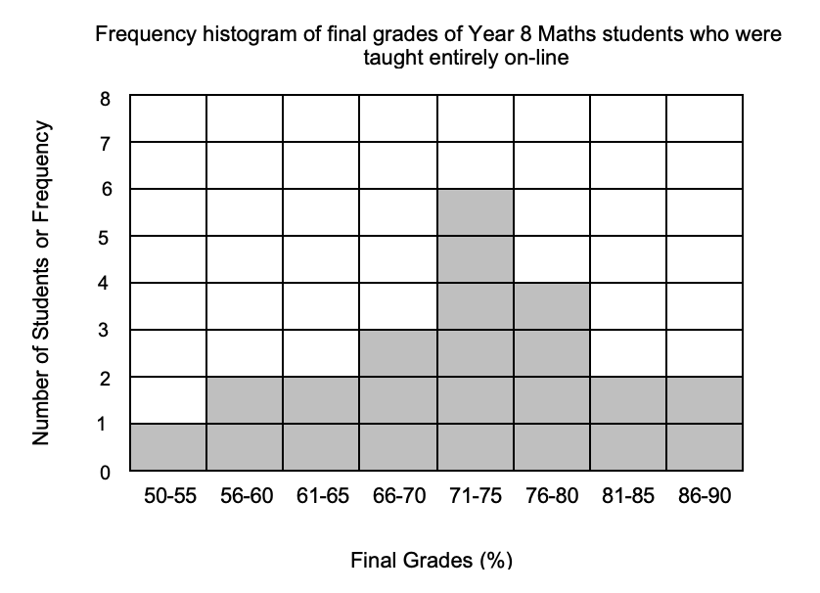

|  |  |
| --- | --- |
| **Description** | **Marks** |
| Title - must include the population (Yr 8 Maths students taught on-line) and the variable measured (frequency of final grades) | 1 |
| Axes - both horizontal and vertical axes must be correctly labelled | 1 |
| Scale - must be evenly distributed, x-axis grouped uniformly | 1 |
| Plotting - each category/group of final grades must have the correct frequency (or number of students) | 1 |
| Used the correct graph type (a histogram) | 1 |
| **Total** | **5** |

Question 2 (cont.) (14 marks)

1. A statistical comparison of the percentage of final grades of Class X and Class Y is given in the table below. Fill in the missing information for Class Y using the percentage of final grades of each student based on the raw data provided in (c). (2 marks)

|  |  |  |
| --- | --- | --- |
| **Statistical Measure** | **Class X**  **(face-to-face teaching)** | **Class Y**  **(online teaching)** |
| **Mean** | 61.2 | **71.4** |
| **Median** | 61 | **74** |
| **Std Dev** | 11.6 | 9.3 |

Mr Banner was not entirely convinced about what his results showed and looked for possible sources of error. He found that 90% of his students who were attending school on-site (Class X) had a parent who worked away from home most of the time and the parent staying home did not have a university education. In contrast, parents of students who did the course entirely online (Class Y) had parents who were university graduates and were home most nights of the week.

1. How did the parents’ work schedule and educational background become a source of error in Mr Banner’s results? (2 marks)

|  |  |
| --- | --- |
| **Description** | **Marks** |
| The parents’ educational background and work schedule was influencing his students’ test results | 1 |
| The difference in final grades may not be due to the way the lessons were taught. | 1 |
| **Total** | **2** |

1. Mr Banner wants to repeat his investigation in the next school year. How can he improve his investigation to make sure that the source of error would be eliminated? (2 marks)

|  |  |
| --- | --- |
| **Description** | **Marks** |
| Select participants whose parents have similar educational background (all with a university education OR all without a university education) AND | 1 |
| Parents have similar working hours (at least one parent is home when students are home OR at least one parent is away most of the time) | 1 |
| **Total** | **2** |

**Question 3 (10 marks)**

It was free dress day at school and Melissa wanted to go as her favourite football player, but all of her friends decided to go as their favourite singers. On the day Melissa changed her mind and decided to go as Katy Perry.

1. Identify the type of influence that made Melissa change her mind. (1 mark)

|  |  |
| --- | --- |
| **Description** | **Marks** |
| Accept ANY of the following:   * Conformity * Normative social influence * Identification | 1 |
| **Total** | **1** |

1. Explain the type of influence you stated in part (a). Refer to a psychological theory in your response.

(5 marks)

|  |  |
| --- | --- |
| **Description** | **Marks** |
| Conformity = Changing behaviour in response to group pressure  Normative Social Influence = The influence of other people that leads us to conform in order to be liked and accepted by them  Identification = people change their attitudes or behaviours because they want to establish or sustain a satisfying relationship with another person | 1 |
| Any TWO of the following:   * Very few people like standing out and looking different from others around them * When we conform to group standards in order to be part of a group and be accepted by the group, we are experiencing normative social influence * Friendship groups in particular exert the strong influence on the ways we dress, speak and behave * Breaking social norms can lead to disapproval or exclusion from the group | 1 - 2 |
| Study: Asch’s Line Judgement Task OR Kelman | 1 |
| Asch concluded that people conform for two main reasons:   * People want to fit in with the group * People believe the group is better informed than they are   OR  Kelman claims that people develop their social identity as they interact with society | 1 |
| **Total** | **5** |

1. Identify and explain **two (2)** factors that can influence Melissa’s decision. (4 marks)

|  |  |
| --- | --- |
| **Description** | **Marks** |
| Any TWO of the following:   * Informational social influence (1) = The change in behaviour or opinions that occurs when we conform to people who we believe have accurate information (1) * Normative Influence (1) = The influence of other people that leads us to conform in order to be liked and accepted by them (1) * Group size (1) = rates of conformity increase as the group size increases, with groups of three to five members having the highest conformity level (1) * Unanimity (1) = When all members of a group behave a certain way, or share the same attitude, it is more likely that an individual will conform. | 1 - 4 |
| **Total** | **4** |
| Only award marks for explanation if linked to scenario. DO NOT ACCEPT culture, deindividuation or social loafing as they are not relevant to the scenario given | |

Question 4 (5 marks)

Below is an advertisement for a popular breakfast cereal. Food advertisers use persuasive communication to increase the amount of products sold. Unfortunately, not all food is good for us and parent’s undergo cognitive dissonance every day when purchasing food for their children.

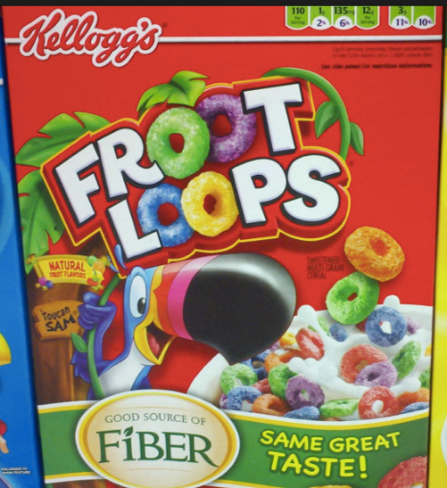

1. Define the term cognitive dissonance. (1 mark)

|  |  |
| --- | --- |
| **Description** | **Marks** |
| The feeling of tension when holding two conflicting views or opinions. The goal is to resume cognitive consistency. | 1 |
| **Total** | **1** |

1. Identify and describe two (2) responses to cognitive dissonance a parent may have when buying the cereal.

(4 marks)

|  |  |
| --- | --- |
| **Description** | **Marks** |
| Any TWO of the following:   * Changing beliefs (1): People can acquire new information to outweigh dissonance beliefs. Parent can learn about the benefits of fibre included in diet. (1) * Changing behaviour (1): parent stops buying cereal because they know that the sugar outweighs the fibre (1) * Changing perception of the action (1): Increase the attractiveness of the chosen alternative and to decrease the attractiveness of the rejected alternative. Parent justifies decision of buying cereal because it contains some fibre and some fibre is better than none. (1) | 1 - 4 |
| **Total** | **4** |
| Only award marks for explanation if linked to scenario. | |

**END OF SECTION ONE**

# Section Two: Extended Response 30% (22 marks)

This section has **one** part.

You must answer **one** question.

Supplementary pages for planning/continuing your answers to questions are provided at the end of the Question/Answer booklet. If you use these pages to continue an answer, indicate at the original answer where the answer is continued, i.e. – give the page number.

Suggested working time for this section is 20 minutes.

**Question 4 (22 marks)**

In the heart of Riverton, a fire erupted in an old, timber-framed house. John, a seasoned firefighter, noticed the smoke immediately, and without hesitation, he grabbed the closest fire hose and directed a stream of water towards the flames. Mary, a young nurse from the local clinic, saw the fire on her way to work. As the crowd gathered and anxiously watched the fire, she glanced around at the concerned faces and hesitated, unsure if she should step forward to offer her newly acquired medical expertise. Meanwhile, Peter, a retired accountant, observed from the sidelines, questioning the significance of the fire's impact and meticulously weighing the costs and benefits of getting involve.

* Explain the difference between anti-social and pro-social behaviour. (2 marks)
* Summarise the aim and findings of the Smoke -Filled Room experiment conducted by Latane & Darley (1968). (4 marks)
* Explain why Mary hesitated to intervene in the emergency. (2 marks)
* Describe an example of anti-social behaviour from the scenario and explain one factor that influenced this response. (5 marks)
* Identify and explain one factor that contributed to the likelihood of pro-social behaviours occurring using an example from the scenario. (5 marks)
* Quality of response (4 marks)

|  |  |
| --- | --- |
| **Description** | **Marks** |
| **Difference between anti-social and pro-social behaviour** | |
| Antisocial behaviour = Behaviours that harm society and its members by intentionally violating the rights of others | 1 |
| Prosocial behaviour = Voluntary actions that promote social acceptance and benefit society and its members | 1 |
| **Subtotal** | **2** |
| **Findings of Smoke -Filled Room experiment** | |
| To observe the behaviour of bystanders in an emergency | 1 |
| Any THREE of the following:   * 75% of participants who were alone reported the smoke * 10% of participants who were in a group with 2 passive confederates reported the smoke * 38% of participants who were in a group of 3 reported the smoke * During the final interviews, participants stated that they took little notice of the reaction of others in the room, and did not admit, or were unaware, that the people in the room influenced their behaviour. * Most explained that they did not act because they did not believe there was an emergency | 1 - 3 |
| **Subtotal** | **4** |
| **Explain why Mary hesitated to intervene in the emergency** | |
| Any ONE of the following:   * Audience inhibition (1) - Failure to intervene in an emergency in the presence of others due to fear of being negatively judged. Mary was relatively new to her job so may not have known how to intervene correctly (1) * Cost-benefit analysis (1) - Weighing up the benefit of performing a behaviour, with the potential cost of the behaviour. Mary may have believed the costs of intervening may be worse than the benefits (1) * Diffusion of responsibility (1) – A reduction in personal responsibility when in a group, resulting in the individual being less likely to act. Mary could see others there and may have assumed someone more experienced than her would act. (1) | 1 - 2 |
| **Subtotal** | **2** |
| **Example of anti-social behaviour from the scenario and explain one factor that influenced this response** | |
| Peter didn’t think the fire was an emergency | 1 |
| Any ONE of the following:   * Audience inhibition (1) - Failure to intervene in an emergency in the presence of others due to fear of being negatively judged. (1) * Social influence (1) – inactive bystanders inhibit the helping of others and believe that if others are not intervening in this situation, then it must not be an emergency | 1-2 |
| Links to scenario | 1 - 2 |
| **Note – accept other relevant response** | |
| **Subtotal** | **5** |
| **One factor that contributed to the likelihood of pro-social behaviours occurring using an example from the scenario** | |
| John helped in the emergency | 1 |
| Any ONE of the following:   * Social responsibility (1) - Individuals are accountable for acting in a way that benefits society (1) * Competence (1) - An individual who believes they have the ability to help others is more likely to do so (1) * Mood (1) - If an individual is in a positive mood, they carry out pro-social behaviours to maintain it (1) * Altruism (1) - Helping others without expecting any personal reward (1) | 1-2 |
| Links to scenario | 1 - 2 |
| **Note – accept relevant response** | |
| **Subtotal** | **5** |
| **Quality of written response** | |
| Coherent and logically ordered paragraphs. Appropriate psychological terminology used consistently and correctly. Punctuation/grammar consistently correct. (Does not need essay style broad introduction or conclusion for full marks) | 4 |
| Candidate writes coherent and logically ordered paragraphs. Uses a range of psychological terminology that is mostly correct. There may be some errors in punctuation/grammar evident, but these do not impede meaning | 3 |
| Candidate writes using clear paragraphs. Uses simple psychological terminology. There may be some errors in punctuation/grammar evident, but these do not impede meaning. | 2 |
| Candidate writes a response that attempts to use paragraphs, uses limited psychological terminology correctly and/or may have limited correct use of punctuation and grammar. | 1 |
| **Subtotal** | **4** |
| **Overall total** | **22** |

**END OF TEST**